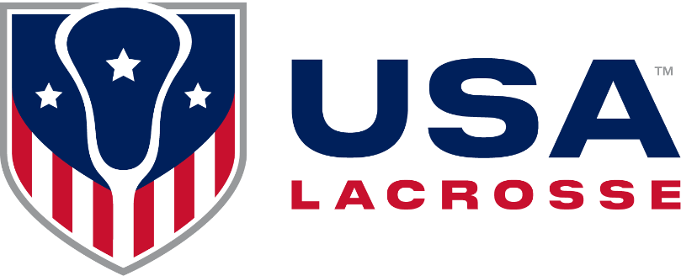
2022 Girls’ Lacrosse
Three-Person Pre-Game Checklist

Pre-Game Responsibilities
- Park near each other and walk into game site as a crew
- If a partner is delayed, communicate ETA and discuss next steps
- Only enter the site without your partner if it compromises your ability to be ready by game time
- Walk the field: check the nets for holes, check the field for correct markings; cones/flags at corners
- Meet with the scorer and timer to ensure they understand their responsibilities and that all needed equipment is in place and working
- Confirm presence and location of site manager and healthcare worker
- Confirm that game balls are NOCSAE-certified

Key Rule Changes in 2024
- Be sure the ball rolls freely in all areas of the pocket when conducting a stick check.
- The game will consist of four 12-minute quarters, with up to a 10-minute halftime and 2 minutes between Q1 and Q2 as well as Q3 and Q4
- When the whistle blows for a foul outside the CSA the ball carrier does not need to come to a stop or settled stance before self-starting.
- Defensive player awarded a free position in the CSA may self-start unless the game clock is stopped.
A false start foul is no longer a foul unless it is in the Critical Scoring Area.

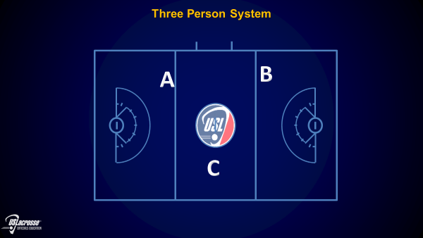
Delay of Game Card Progression

1st Green: Change of possession

2^{nd.} Green/Yellow: 2-minute penalty
No substitution

3rd + Yellow: 2-minute penalty
No substitution
Card included in
team card count

Suggested Pregame Protocol
(Officials arrive 30 minutes before game time)
Real Time Clock Time Activity
4:20 30:00 Field Open
4:45 05:00 Captains’ Meeting
4:50 00:00 Clear field/stick checks
4:55 00:00 Lineups Announced
4:57 00:00 National Anthem
5:00 00:00 Opening Draw

2023 Points of Emphasis

- Sportsmanship

- Knowledge of the Rules

- Dangerous Use of the Stick
Communication
- With coaches during pre-game, halftime, timeouts
- Before draw, after goals, if players
are on the ground
- Throughout game with eye contact, signals, direction
- Always supportive, never challenging

Deep Trail (A or B) - Primarily off ball
- Position: Follows play
- Transition: Follows play up field
- In CSA: Manages goalie clear
- CSA Movement: Adjusts relative to ball and C
- Top of Mind: Shooting Space, off-ball holds/detains, illegal picks, 3 seconds, RL, Shooting Space, fouls after shot
C - On or off ball, depends on ball location
- Position: Second Lead and Second Trail
- Transition: Escorts play
- In CSA: on/off-ball as ball moves
- CSA Movement: Adjusts relative to ball and DT
- “Releases” new Lead at RL in transition
- Top of mind: Goal Circle fouls, Holding, Illegal
Picks, 3 Seconds, offside, Shooting Space, fouls after shot OR on-ball fouls when ball on C side

Lead (A or B) - Primarily on ball
- Position: Open to receive play
- Transition: Move to stay ahead of play
- In CSA: Whistles all restarts
- CSA Movement: Adjusts to the ball
- Goals: Confirm with partners, whistle/signal
- Top of Mind: On-ball fouls OR 3 Seconds, Illegal Picks, Holding when ball on C side

Coaches’ And Captains’ Meeting
- Coaches must certify players are legally equipped and equipment is NOCSAE- and ASTM-certified: Goggles ASTM 3077, Headgear ASTM 3137
- Coin toss for first Alternate Possession or choice of end to defend. Make sure AP indicator is correctly set after coin toss.
- Conduct stick checks in accordance with most recent procedures and consistently among all partners. Allow time for quick fixes.
- Do a visual check on all players to ensure they have no jewelry (cannot be covered by tape or bandages) and that mouthguards and other protective equipment are visible.

Suggested Pre-Game Topics

Coverage on the Draw
Off-Ball Responsibilities
Trail and C support around the arc
Goal Circle foul Penalty Administration
3 Seconds Penalty Administration
False Starts: How to Avoid
Setting up RL Fouls
RL as an Offsetting Foul
RL Coverage in Transition
Managing Midfield Play

Managing Restarts Efficiently
Warnings/Cards
Clock Awareness
Stick Check Requests
Fouls After the Shot
Overtime Procedures
Communication/Signals
Alternate Possession
Contentious play
Coach decorum

