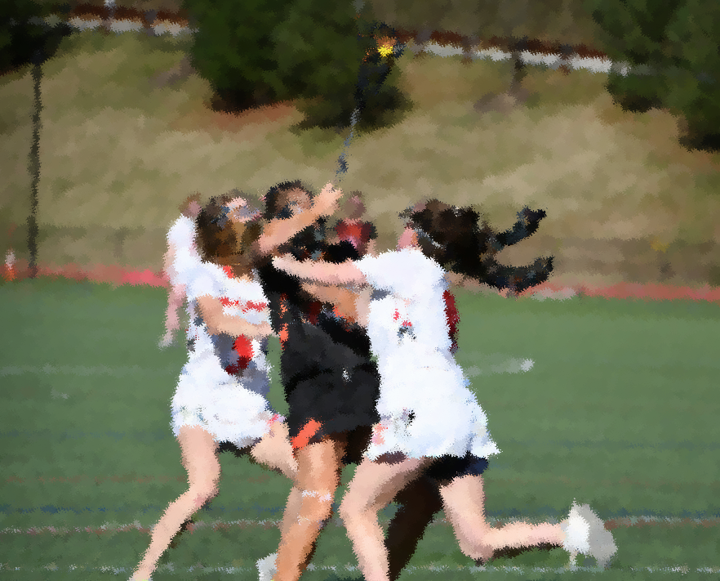

MAjor Fouls

Lesson Plan

ABout this Module

Module Description
In the Major Fouls lesson, students learn how to recognize major fouls and conduct proper penalty administration. Fouls will include common major fouls, including cardable fouls. Students will be introduced to the concept of the Held Whistle.

Module Objectives
Upon the completion of this lesson:
- Students will identify major fouls and the signals associated with the foul
- Students will practice foul administration in and outside the CSA
- Students will start to comprehend the idea of a held whistle

Materials needed
The documents below can be accessed from the links on the cover of this document.
- Acquire and test A/V equipment
- Complete all relevant items on Clinician Pre-Clinic Checklist
- “Major Fouls and held Whistle” PowerPoint presentation
- BREAKOUT GROUPS: “Administer the Major Foul”
- “Girls’ Lacrosse Rule Reference” sheet
- Equipment: sticks and balls

Part I: Major Fouls by defense
Present slides 1-9
Distribute the “Girls’ Lacrosse Rules Reference Sheet” and review the most common major fouls that a NEW official may see. Using sticks and players, demonstrate any that the class needs clarification.

ACTIVITY: Signal
As you go through the fouls, refer to the signals for each one in the rule book. Have the students demonstrate the signal of the most common fouls.

Part II: three seconds & Shooting space
Present slide 10-14
Review the two “unique” major fouls and the criteria needed for calling each foul.

DEMONSTRATION: Three Seconds Foul
Demonstrate a stick’s length from a defender, getting out of the 8m (to stop the count), and double teaming as it relates to Three Seconds foul.

Part III: Major Fouls by offense
Present slides 15-21
Review common Attack major fouls

ACTIVITY: Signal
Refer to the signals for each one in the rule book. Have the students demonstrate the signal of the most common fouls.

Part Iv: penalty Administration
Present slide 22-37
Review the administration of fouls on the vinyl field or white board with the class. Have class verbalize the steps of Penalty Administration.

DEMONSTRATION: Penalty Administration
Demonstrate the steps and signals to efficient penalty administration.

BREAKOUT GROUPS: Administer the Major Foul
In groups of 2-3, practice foul administrations using the “Administer the Major Foul” worksheet. Use the “Penalty Administration by location” and the “Girls’ Lacrosse Foul Reference Sheet” handouts for reference. Try to pick one midfield, one in CSA but outside the 8m and one on the 8m.

Part V: Held Whistle
Present slides 38-43
Discuss what ‘Advantage’ means in the women’s lacrosse game with relation to the defensive foul on a scoring play.

DISCUSSION: Scoring Play
Ask the group to define a ‘scoring play’

Note: In no way will new officials be expected to use their flag at this early stage of officiating. This section introduces the concept to new officials.

REVIEW
- Students can recognize a major foul, signal it and set up the restart.
- Students have a general understanding of a slow whistle.

