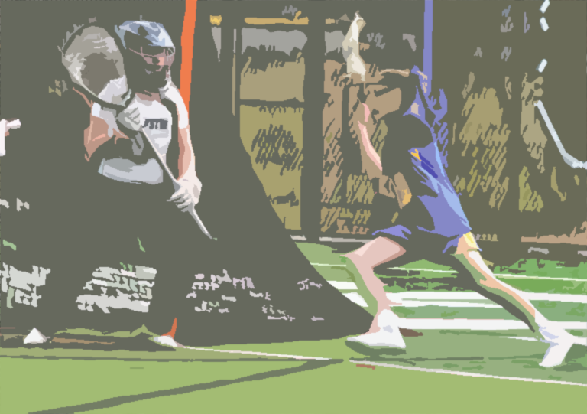

Goal Circle Fouls

Lesson Plan

GOAL CIRCLE FOULS

GOAL CIRCLE FOULS RESOURCE FOLDER

ABout this Module

Module Description
In the Goal Circle Fouls lesson, students learn what categorizes a foul as a goal circle foul; proper penalty administration for goal circle fouls.

Module Objectives
Upon the completion of this lesson:
- Students will recognize goal circle fouls
- Students will demonstrate how to administer goal circle fouls, by both offense and defense, in the midfield, CSA, and below the GLE

Materials needed
The documents below can be accessed from the links on the cover of this document.
- Acquire and test A/V equipment
- Complete all relevant items on Clinician Pre-Clinic Checklist
- Goal Circle Fouls PowerPoint presentation
- ACTIVITY: “Oh That Goalie” Quiz
- ACTIVITY: “Oh That Goalie” Answer Key
- DEMONSTRATE: Vinyl Field Mat/Players/Officials
- DISCUSSION: Goal Circle Review Questions

Part I: GOAL CIRCLE FOULS
Present slides 1-4

Practice: Goal Circle Fouls Signals
Identify goal circle fouls and practice signal. If outdoors, practice whistle as well!

Part II: GOALIE PLAY/PENALTY ADMINISTRATION
Present slide 5-9

Breakout Groups: “Oh, That Goalie”
Divide class into groups to complete “Oh, That Goalie” quiz. Review/discuss answers.

DISCUSSION: Goal Circle Review
Use the “GC Review Questions” to discuss unique situations surrounding the Goalie and the Goal Circle.

REVIEW
- Who can commit a goal circle foul?
- How are goal circle fouls administered?
- What is special about a goalie (or her deputy) while she is in the goal circle?
- Use “GC Review Questions” to further discussion

