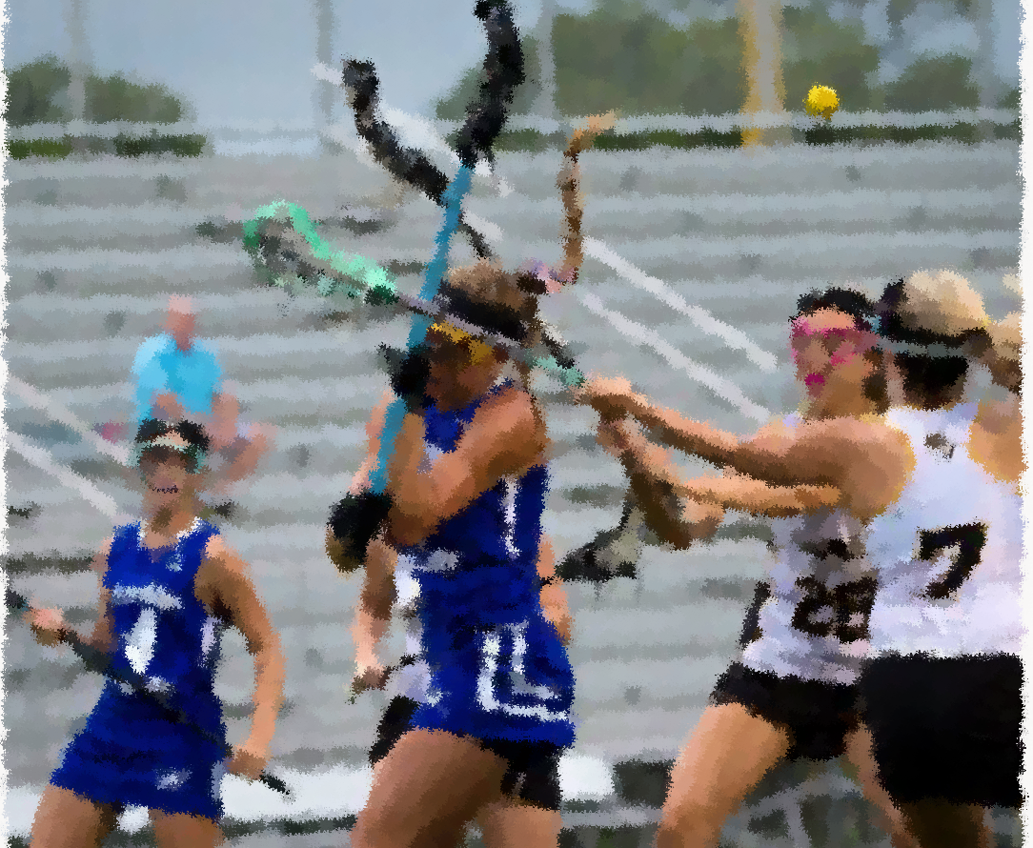

MISCONDUCT and carding

Lesson Plan

ABout this Module

Module Description
In the Misconduct and Carding lesson, students learn how to recognize major cardable fouls including Misconduct and how to properly administer a card.

Module Objectives
Upon the completion of this lesson:
- Students will identify the five mandatory card fouls and one discretionary card foul and the signals associated with them
- Students will practice foul administration in and outside the CSA
- Students will demonstrate the proper techniques of issuing a card

Materials needed
The documents below can be accessed from the links on the cover of this document.
- Acquire and test A/V equipment
- Complete all relevant items on Clinician Pre-Clinic Checklist
- “Misconduct and Carding” PowerPoint presentation
- How to Issue a Card Video

Part I: Cardable Fouls and Misconduct
Present slide 1-8
Review the fouls that warrant a card. Discuss the different Misconduct fouls.

DEMONSTRATION: Cardable Fouls
Review the signal and steps necessary to administer a card. Discuss the difference between Yellow (suspension) and Red (ejection) cards.

Part II: penalty administration/Team cards
Present slides 9-11
Review the proper length of penalties for yellow and red cards.

DISCUSSION: Team Cards
Review the team card penalty criteria. Discuss how to count for offsides during a carding situation.

Part Iii: Goalie carded
Present slides 12-15

ACTIVITY: Where Does The Goalie Go?
Work through the “Where does the Goalie Go?” activity alone or in groups.

Part iV: administering a card
Present slides 16-18

BREAKOUT GROUPS: How to Issue a Card
In groups of 2-3, demonstrate how to issue a card and critique each other. Move around the room and correct any errors or offer suggestions.

REVIEW
- Students can recognize misconduct and issue a card.
- Students can properly administer a free position for Goalie Misconduct.

